Math 8 Application 9 Name ________________________
Show all your work!
1. Circle the letter that represents the approximate location on the number line of $\sqrt{30}$.  A B C D  0 5 10 15 | 2. Simplify without a negative exponent:  4⁻³ = | 3. Solve for x:  x³ = 125
4. Write in scientific notation.  782,000,000 | 5. Write the difference in scientific notation.  (8.7 ∙ 10⁵) - (3.5 ∙ 10⁵) = | 6. Solve for x.  9x – 25 = 12x + 10
7. What type of transformation of Figure A resulted in Figure B?  A B | 8. Find the length of side a below.  a 10 in.  7 in. | 9. Find the measure of angle b.  b  27◦
10. Put the following numbers in order from smallest to largest.  150%, 1 ¼, 1.7, 1.5% | 11. Estimate the sum below.  985,890 + 678,945 | 12. Write as percent.  1.25
13. Mark made a pattern with tiles as shown below. Write an equation for the function.  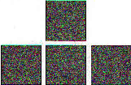 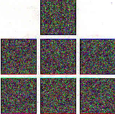 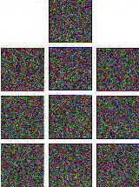Stage 1 Stage 2 Stage 3 | 14. Graph Mark’s function.  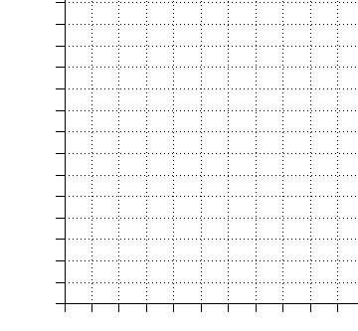 | 15. Complete the table.
  Stage | Total tiles
  1
  2
  3
  5
  10
16. What is the sale price of a pair of $30 jeans that is marked 40% off? | 17. What is the volume of a sphere with a circumference of 10$π$? | 18. A champion hot dog eater, Joey Chestnut, ate 62 hot dogs in 53 seconds. At this rate, how many hot dogs could he eat in 5 minutes?
19. Juan’s quiz scores are 17, 18, 15, 19, and 12. What is the mean of his quizzes? | 20. A triple jumper traveled 5 yards on his first jump, 10 feet on the second jump, and 5 feet on the final jump. How many total yards were traveled. | Number correct  5 minutes_______  Total___________

